SIMATS ENGINEERING
Assignment

COURSE NAME: OBJECT ORIENTED ANALYSIS AND DESIGN

COURSE CODE: CSA11

COURSE OUTCOME COVERED

CO1: Analyse the fundamentals of Object-Oriented Systems Development, including
object basics, Object-Oriented Systems Development Life Cycle, Object-Oriented
Methodologies, Model-Driven Development (MDD), and Agile practices.
CO2: Apply UML techniques including Use Case, Class, Interaction, State Transition,
Activity, Package, Component, and Deployment Diagrams to model a software system.
CO3: Analyse objects, classes, attributes, methods, and relationships through Use Case
Modelling, Object Analysis, Classification, and identification of object relationships.

Assignment Weightage: 100%
QUESTIONS: 1 Total Marks: 100
Annexure A
Assignment
Code of Conduct: I A K Selva Prabhu (192421224) (Name / Reg No) certify that this
submission is my original work and that I have adhered to the guidelines specified for
this assessment.
I understand that any violation of academic integrity rules will result in disciplinary
action.
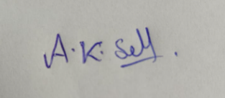
Signature of the student:

Particular | Details
Department: | Information technology
Program: | Bachelor of Technology
Course Code & Course Name | CSA1104 OBJECT ORIENTED ANALYSIS AND DESIGN
Academic Year / Batch | 2026-2027
Faculty Name | A Gayathri
Assignment Title | Object-Oriented Analysis and UML-  Based Design of an AI-Enabled Disaster  Resilience and Emergency Response  Platform (AIDERP)
Course Outcome(s) – CO | CO1: Analyse the fundamentals of  Object-Oriented Systems Development,  including object basics, Object-Oriented  Systems Development Life Cycle, Object-  Oriented Methodologies, Model-Driven  Development (MDD), and Agile  practices.  CO2: Apply UML techniques including  Use Case, Class, Interaction, State  Transition, Activity, Package,  Component, and Deployment Diagrams to  model a software system.  CO3: Analyse objects, classes, attributes,  methods, and relationships through Use  Case Modelling, Object Analysis,  Classification, and identification of object  relationships.
Bloom's Taxonomy Level | BL3 – Apply, BL4 – Analyse, BL5 –  Evaluate, BL6 – Create
SDG Mapping (SDG 1-17) | SDG 3 – Good Health and Well-being  SDG 9 – Industry, Innovation and  Infrastructure  SDG 11 – Sustainable Cities and  Communities  SDG 13 – Climate Action

USECASE
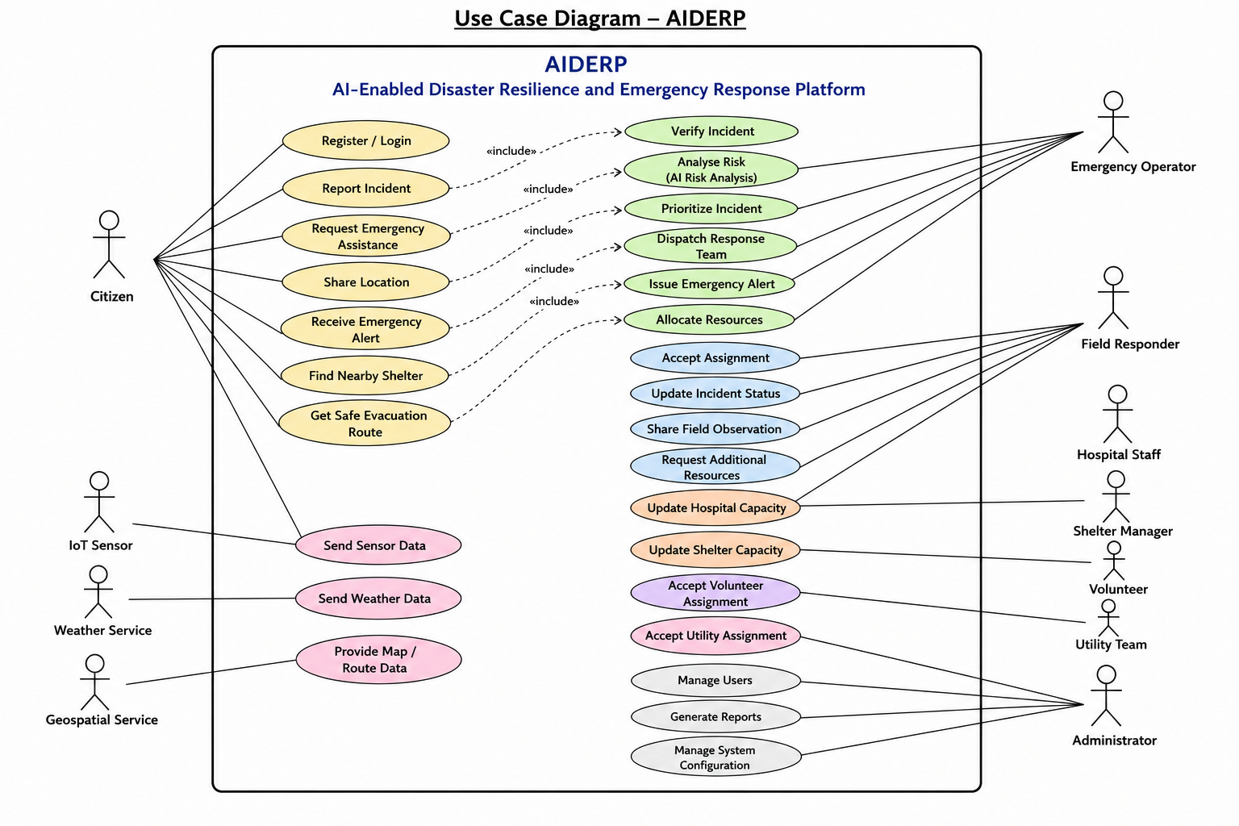CLASS DIAGRAM
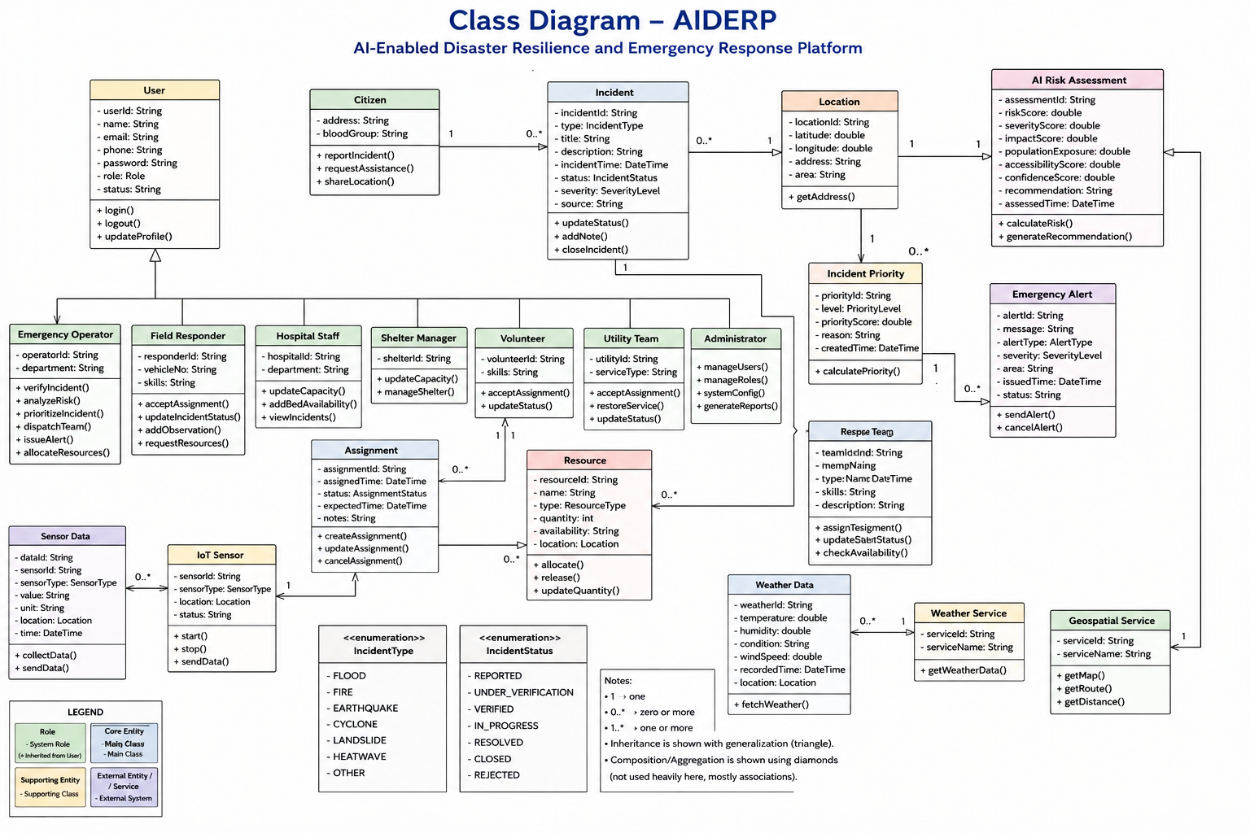

SEQUENCE / INTERACTION DIAGRAM
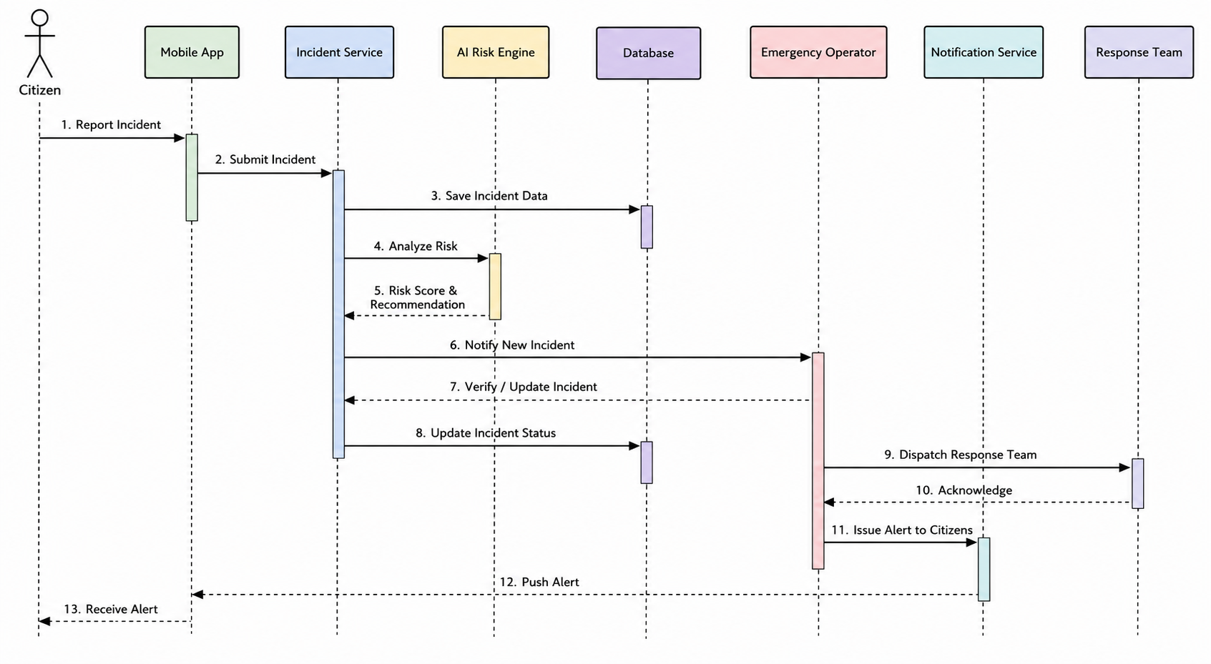
ACTIVITY DIAGRAM
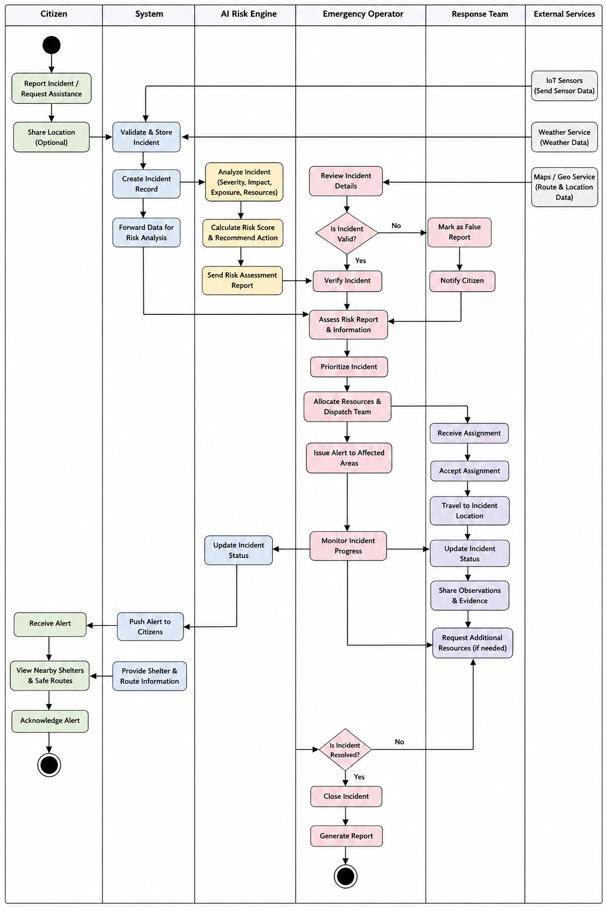

STATE TRANSITION DIAGRAM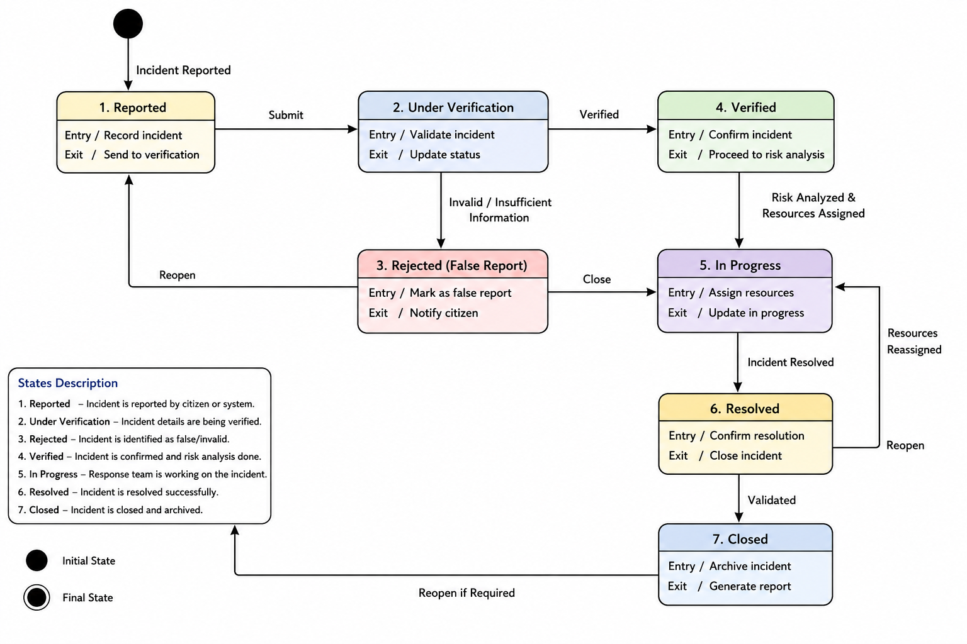
PACKAGE DIAGRAM
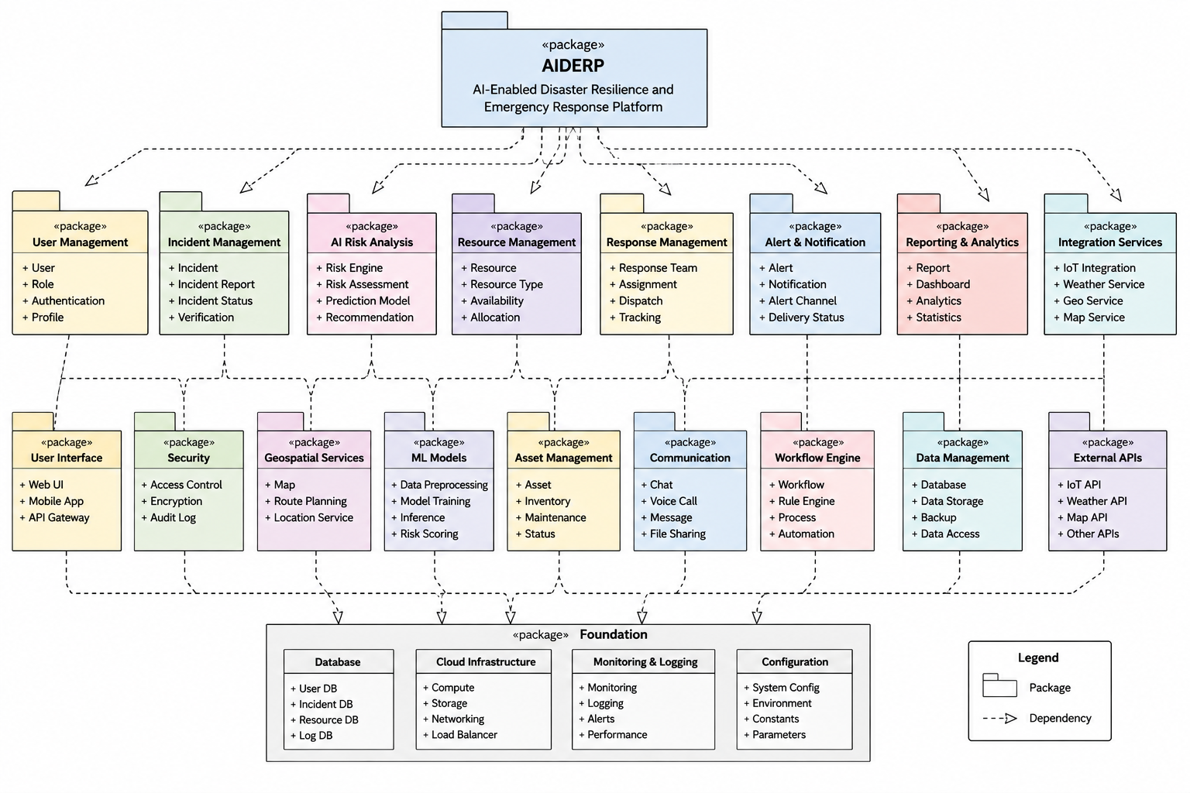

COMPONENT DIAGRAM
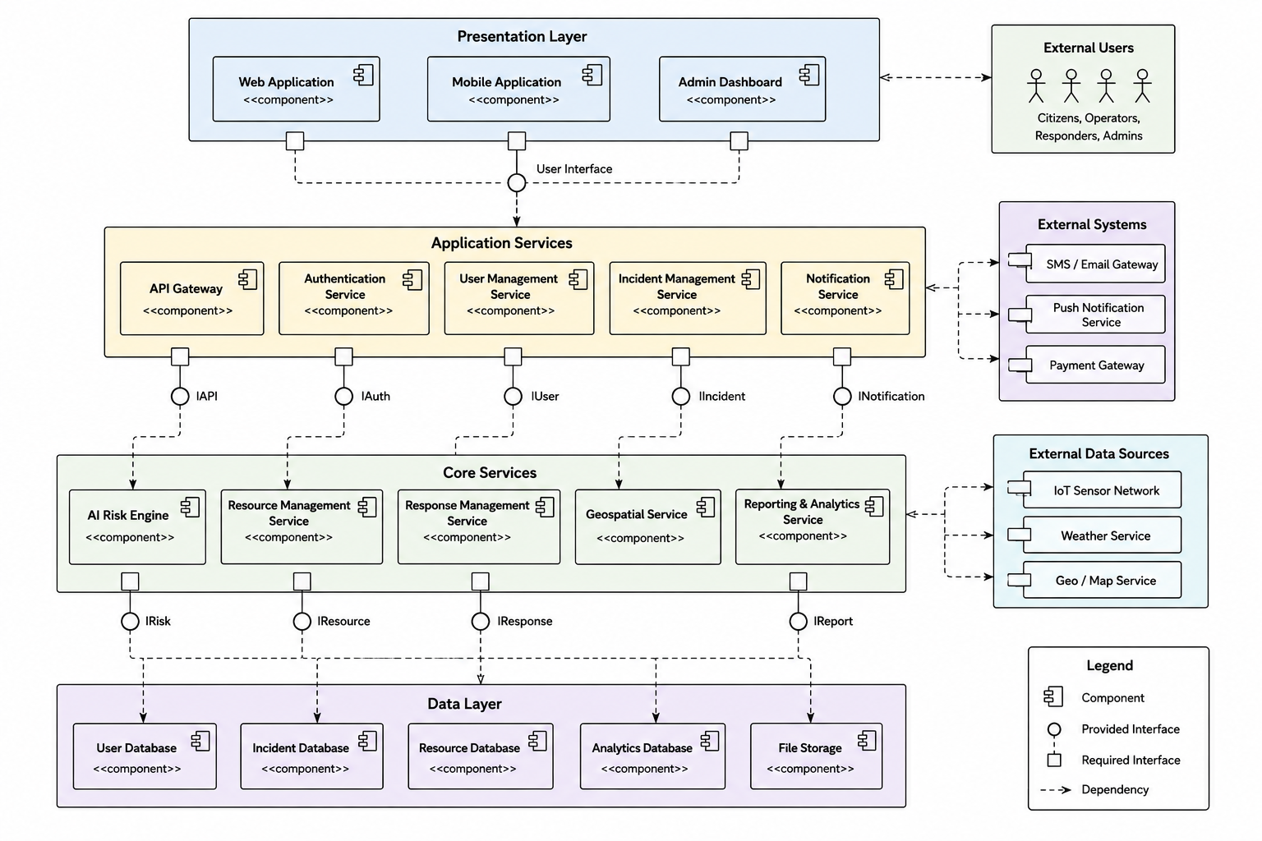
DEPLOYMENT DIAGRAM
